Software Requirements Specification

for

<Fast Nuces Help Desk>

Prepared by <Abdullah Amer>

<Fast Nuces>

<13 March 2023>

Table of Contents

Table of Contents ii

Revision History ii

1. Introduction 1

1.1 Purpose 1

1.2 Document Conventions 1

1.3 Intended Audience and Reading Suggestions 1

1.4 Product Scope 1

1.5 References 1

2. Overall Description 2

2.1 Product Perspective 2

2.2 Product Functions 2

2.3 User Classes and Characteristics 2

2.4 Operating Environment 2

2.5 Design and Implementation Constraints 2

2.6 User Documentation 2

2.7 Assumptions and Dependencies 3

3. External Interface Requirements 3

3.1 User Interfaces 3

3.2 Hardware Interfaces 3

3.3 Software Interfaces 3

3.4 Communications Interfaces 3

4. System Features 4

4.1 System Feature 1 4

4.2 System Feature 2 (and so on) 4

5. Other Nonfunctional Requirements 4

5.1 Performance Requirements 4

5.2 Safety Requirements 5

5.3 Security Requirements 5

5.4 Software Quality Attributes 5

5.5 Business Rules 5

6. Other Requirements 5

Appendix A: Glossary 5

Appendix B: Analysis Models 5

Appendix C: To Be Determined List 6

**SRS DOCUMENTATION**

**1. Introduction**

**1.1 Purpose**

The purpose of this document is to specify the software requirements for the FAST-NUCES Student Portal, a MERN stack-based web application designed to address the challenges faced by FAST-NUCES students in managing various aspects of university life. This document outlines the scope, functionalities, and constraints of the system.

**1.2 Document Conventions**

No specific document conventions are assumed in this SRS. All requirements will have their own priority assigned.

**1.3 Intended Audience and Reading Suggestions**

This document is intended for developers, project managers, testers, and documentation writers. It is organized into sections detailing the overview, functional and non-functional requirements, user stories, and use cases. Readers are encouraged to start with the overview sections and proceed through the sections most pertinent to their role.

**1.4 Product Scope**

The FAST-NUCES Student Portal is a web application aimed at providing FAST-NUCES students with a platform to address common challenges in university life. It includes features such as carpooling, academic resource sharing, anonymous advice, accommodation information, and cross-university discussions. The focus is on anonymity and specialization to cater specifically to FAST-NUCES students' needs.

**1.5 References**

No external references are required for this SRS.

**2. Overall Description**

**2.1 Product Perspective**

The FAST-NUCES Student Portal is a standalone product developed to address the unique challenges faced by FAST-NUCES students. It is not part of a larger system but can be integrated with existing university systems for data exchange purposes.

**2.2 Product Functions**

* Carpooling
* Academic resource sharing
* Anonymous advice
* Accommodation information
* Cross-university discussions

**2.3 User Classes and Characteristics**

User classes include students, moderators, and administrators. Students may vary in technical expertise and frequency of use.

**2.4 Operating Environment**

The software will operate on web browsers compatible with modern standards. It will be deployed on servers supporting Node.js, Express.js, and MongoDB.

**2.5 Design and Implementation Constraints**

Constraints include compatibility with existing university systems, adherence to privacy regulations, and the use of specified technologies (MERN stack).

**2.6 User Documentation**

User documentation will include user manuals and online help integrated within the application.

**2.7 Assumptions and Dependencies**

Assumptions include availability of internet access for users and compliance with university regulations regarding data privacy.

**LEVEL 0 DFD :**

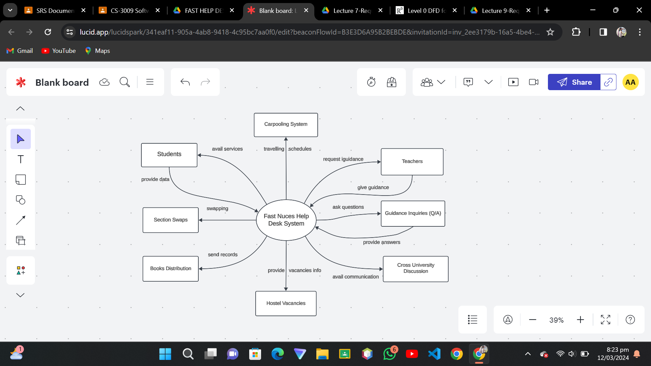

**LEVEL 1 DFD :**

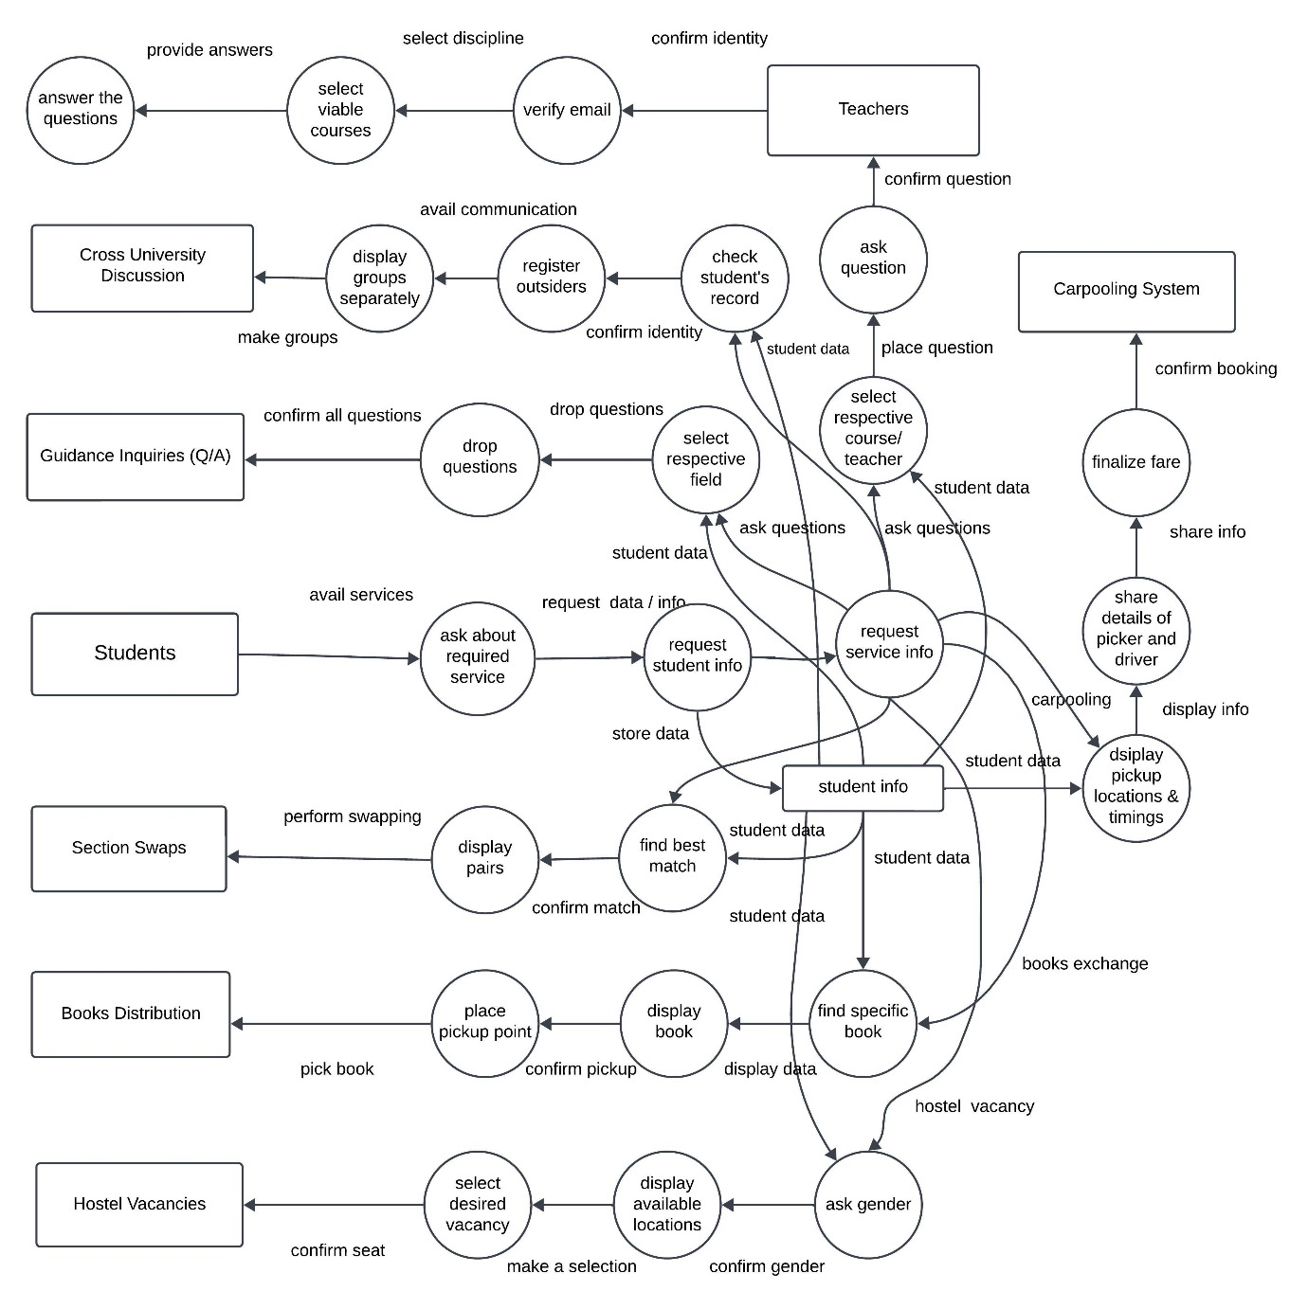

**Class Diagram :**

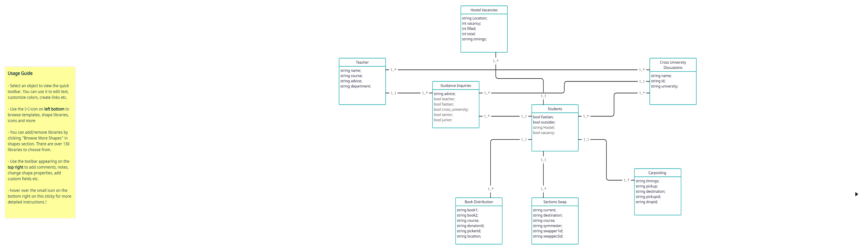

**3. External Interface Requirements**

**3.1 User Interfaces**

The user interface will be designed to be intuitive and easy to navigate, following modern web design principles.

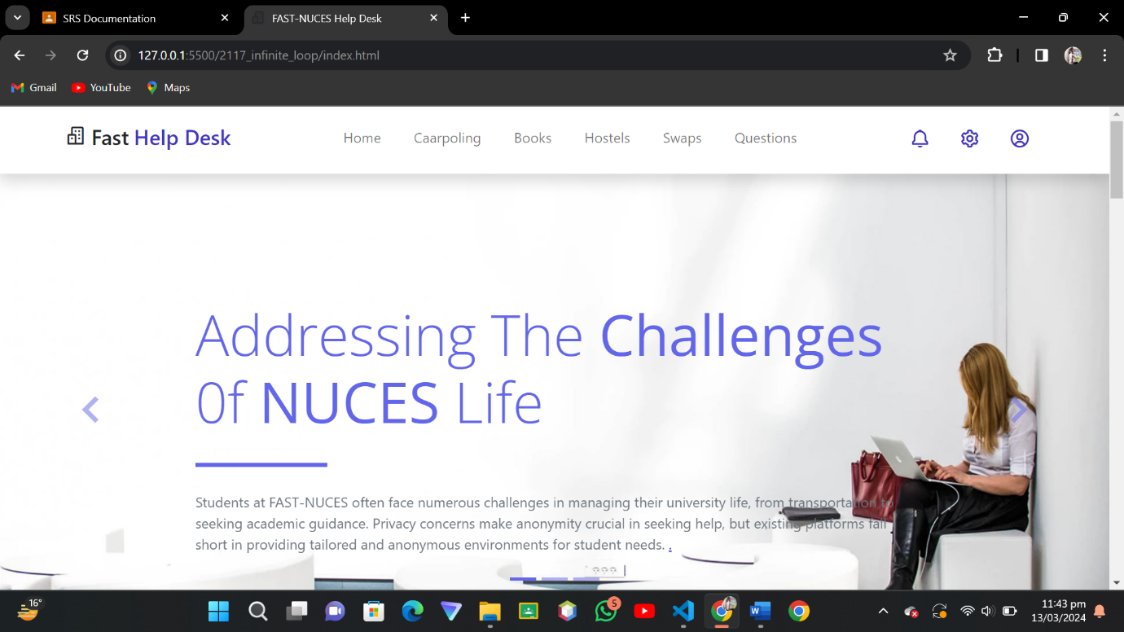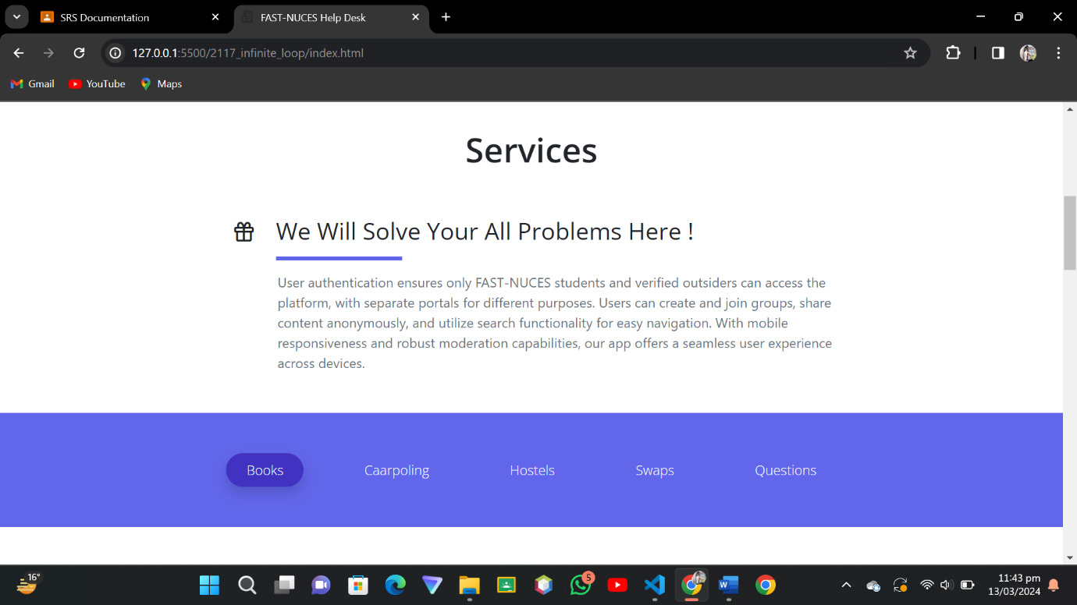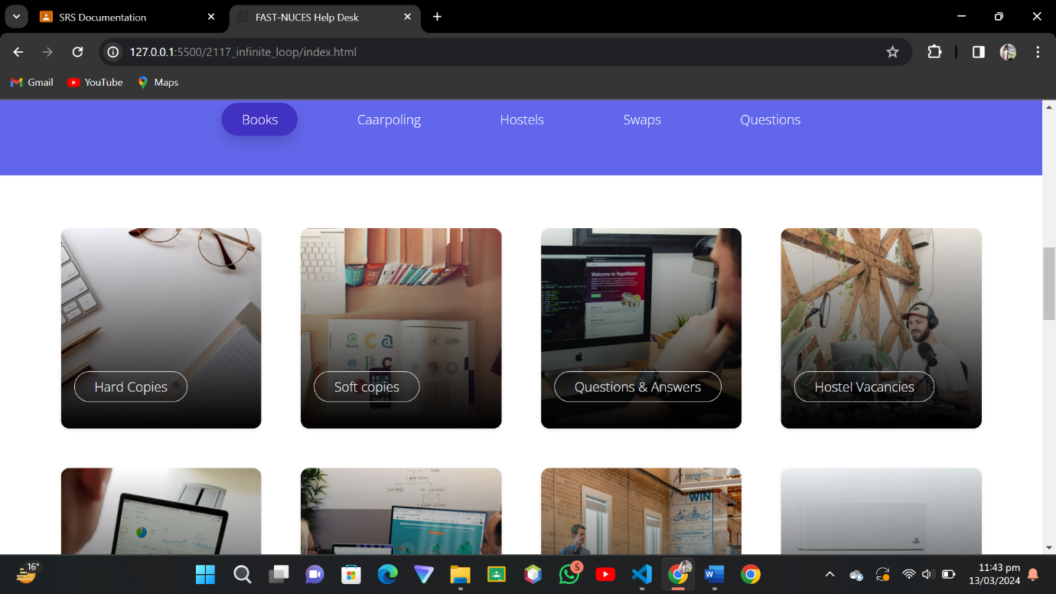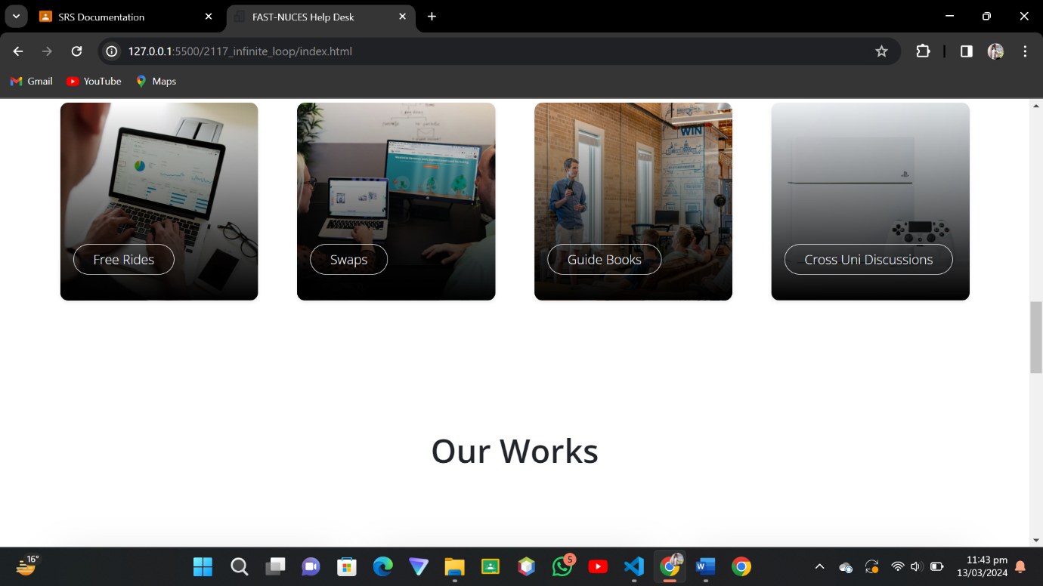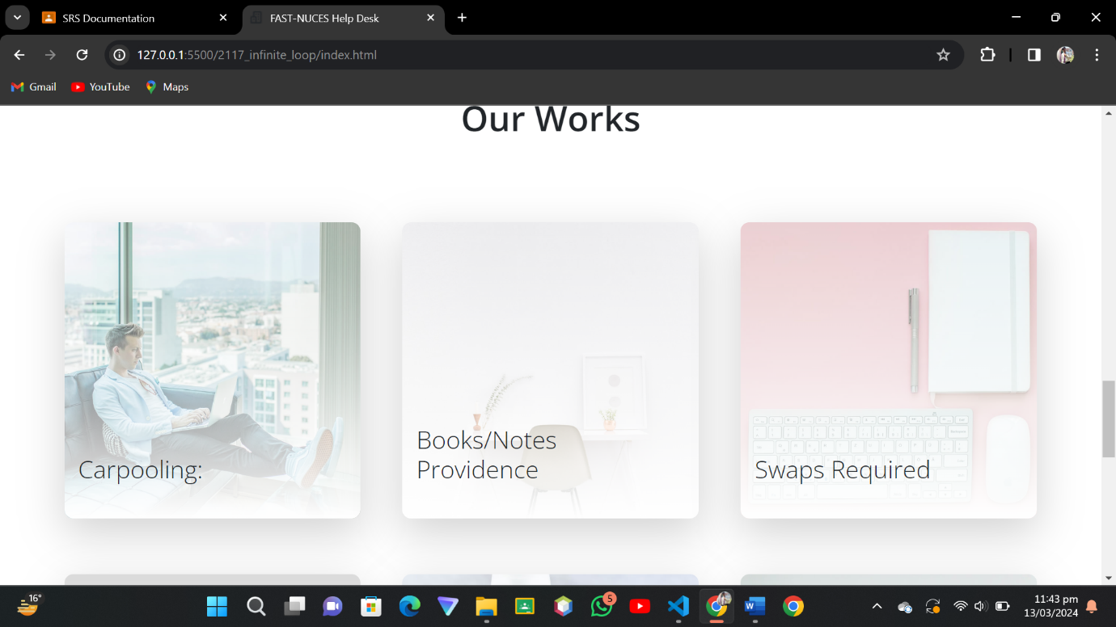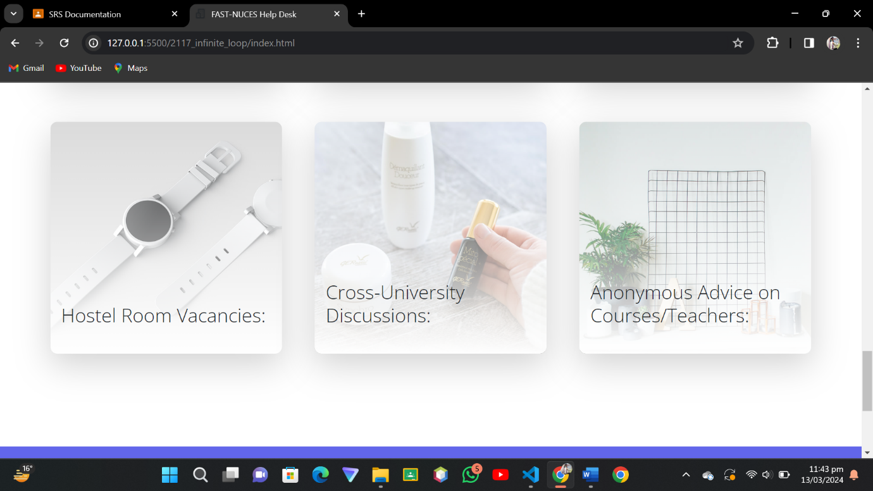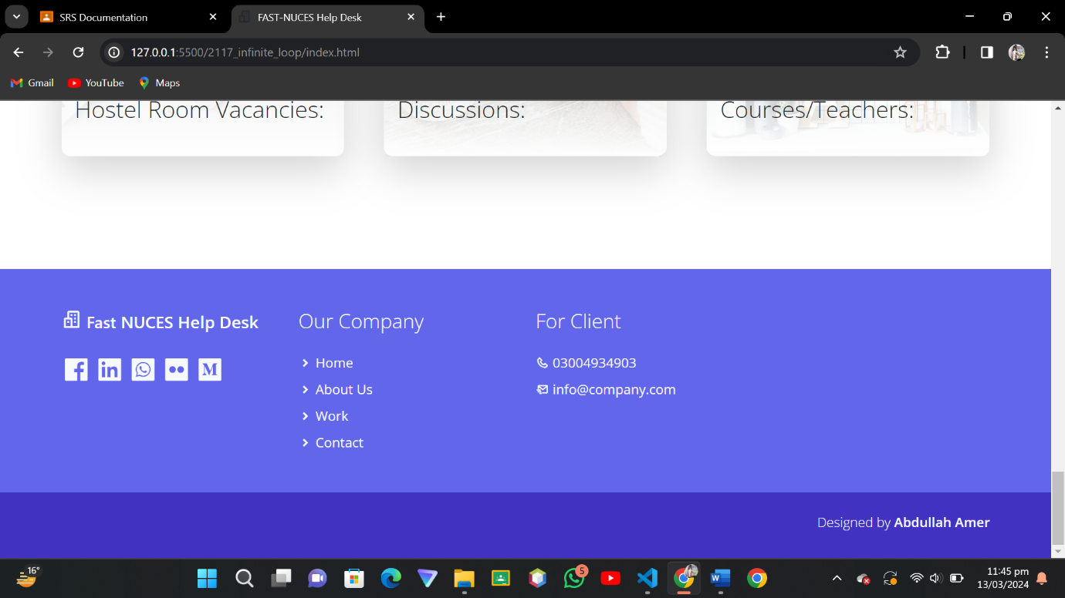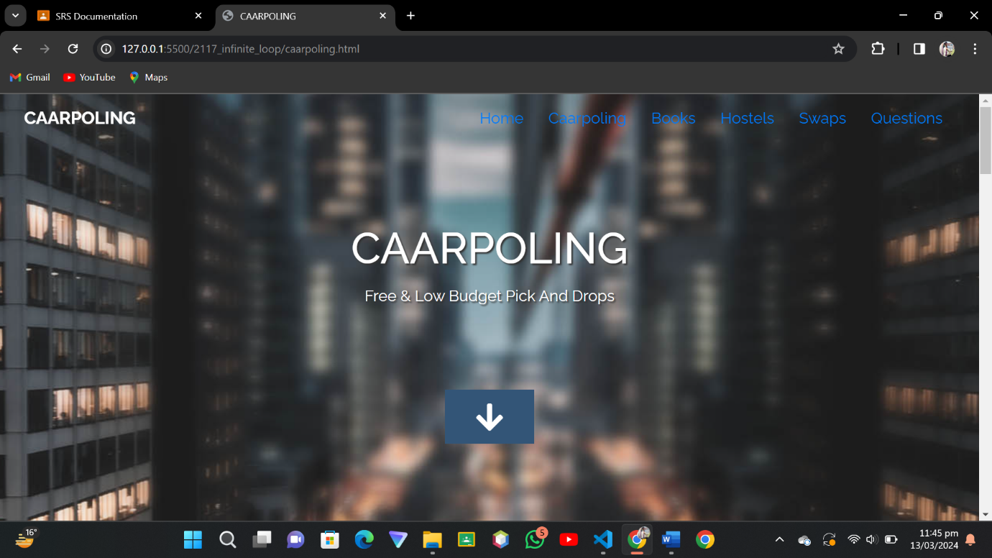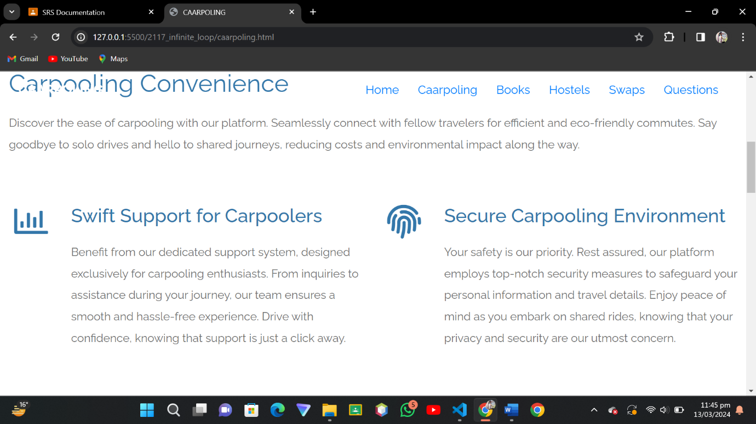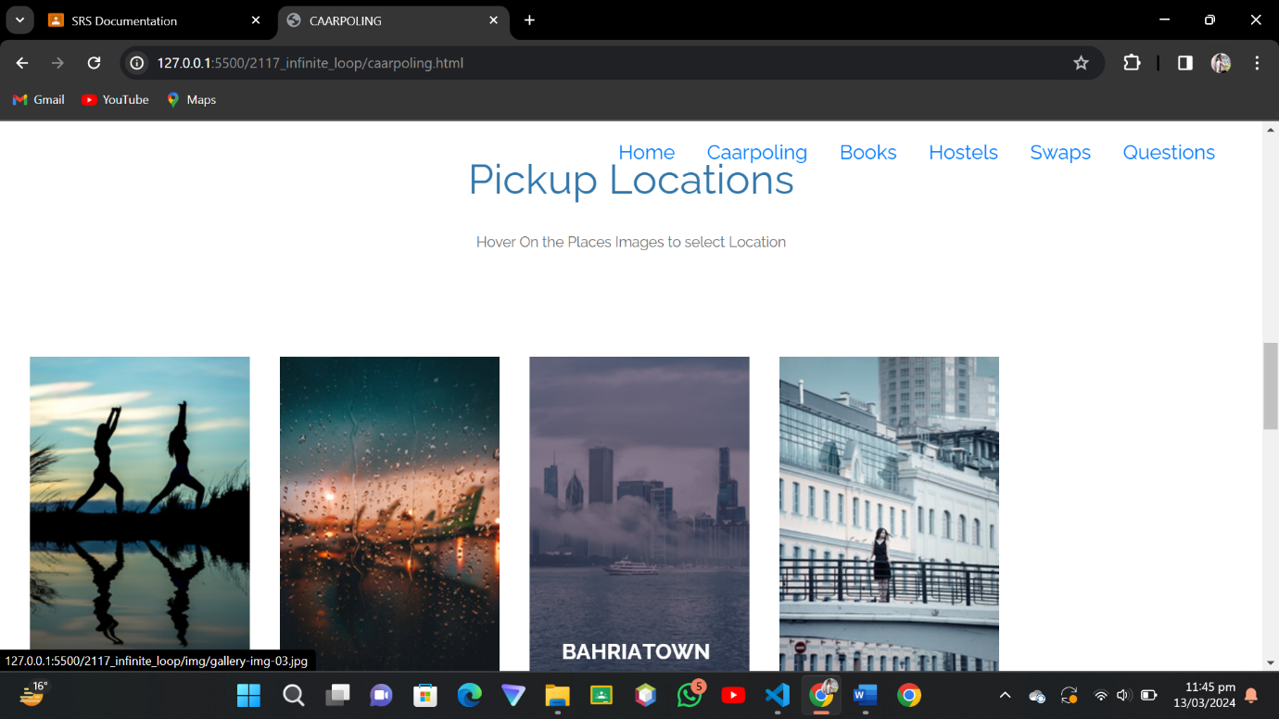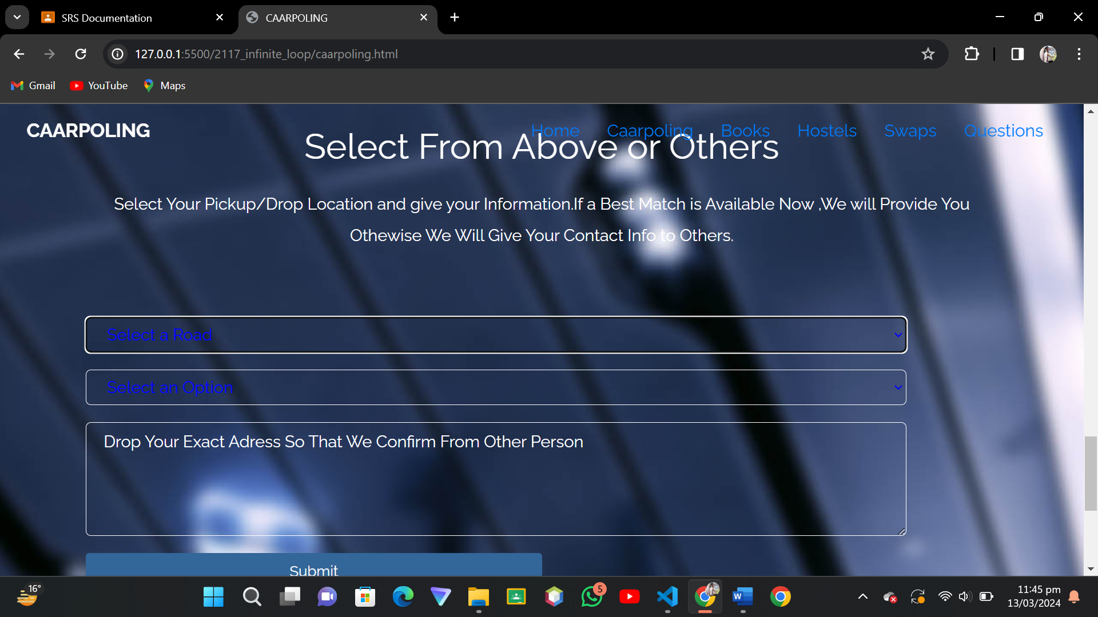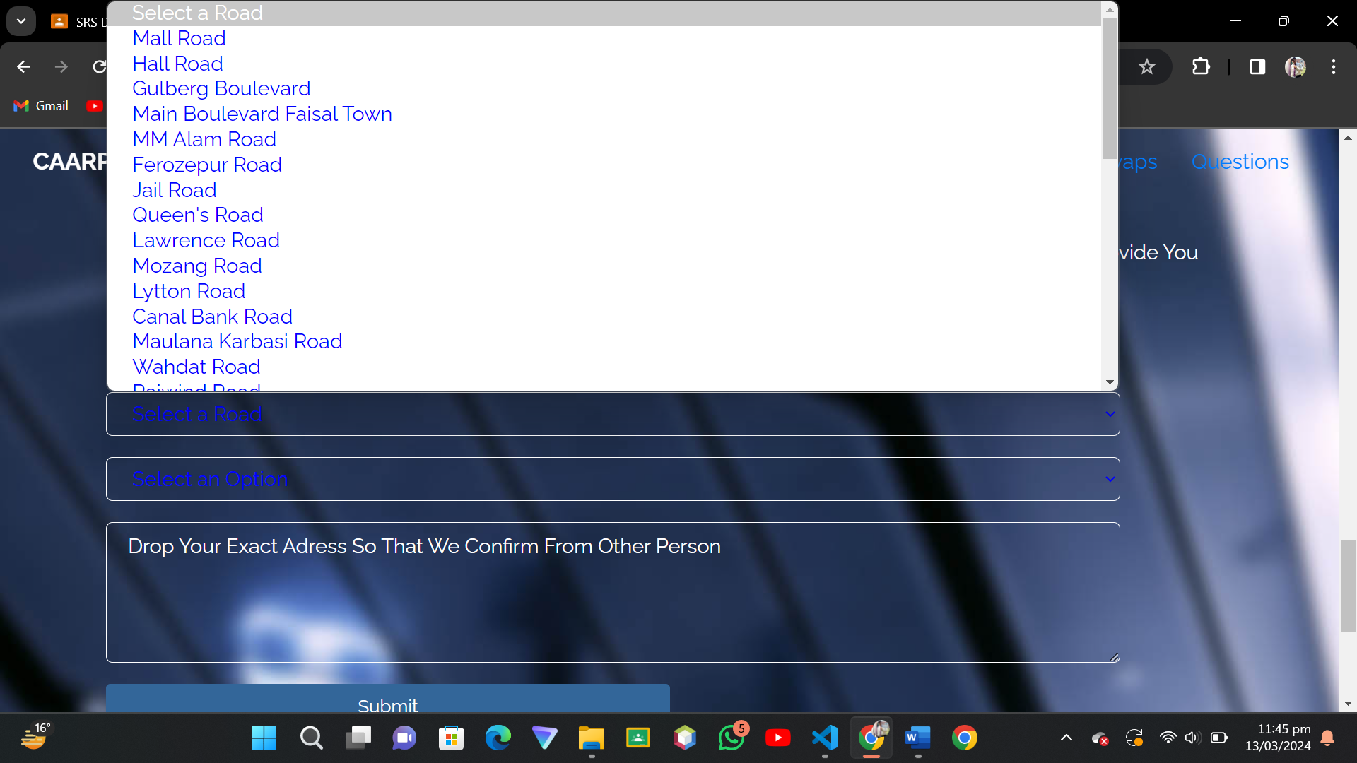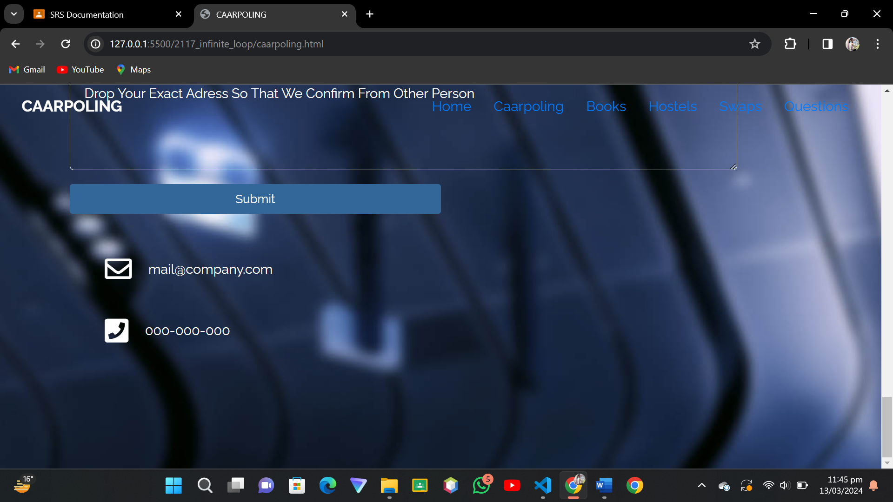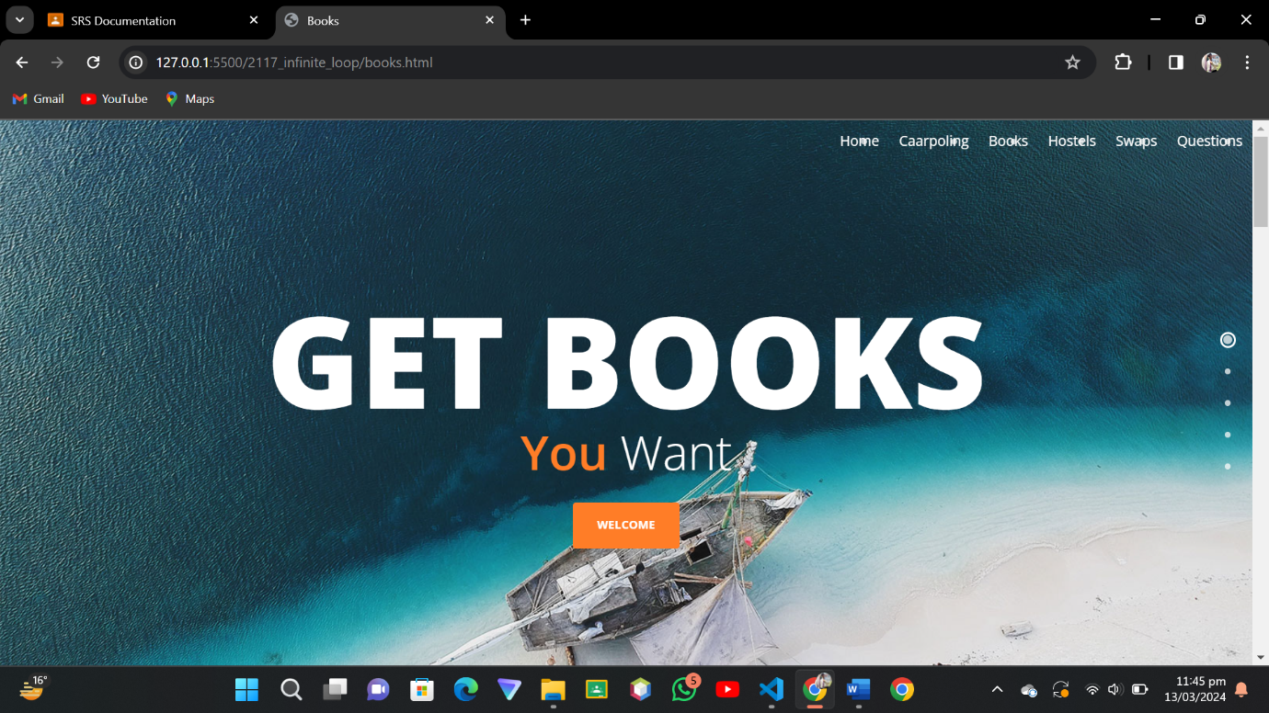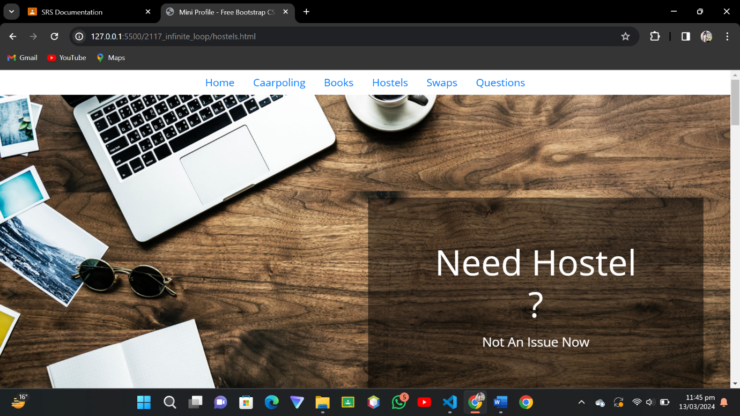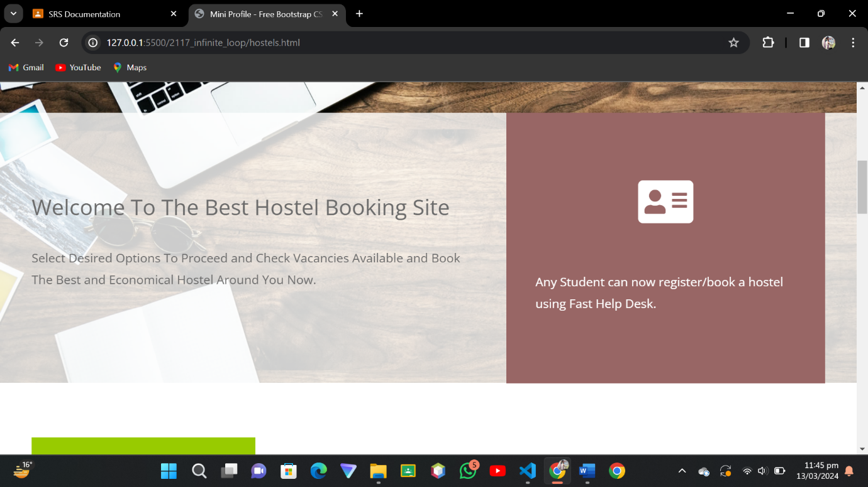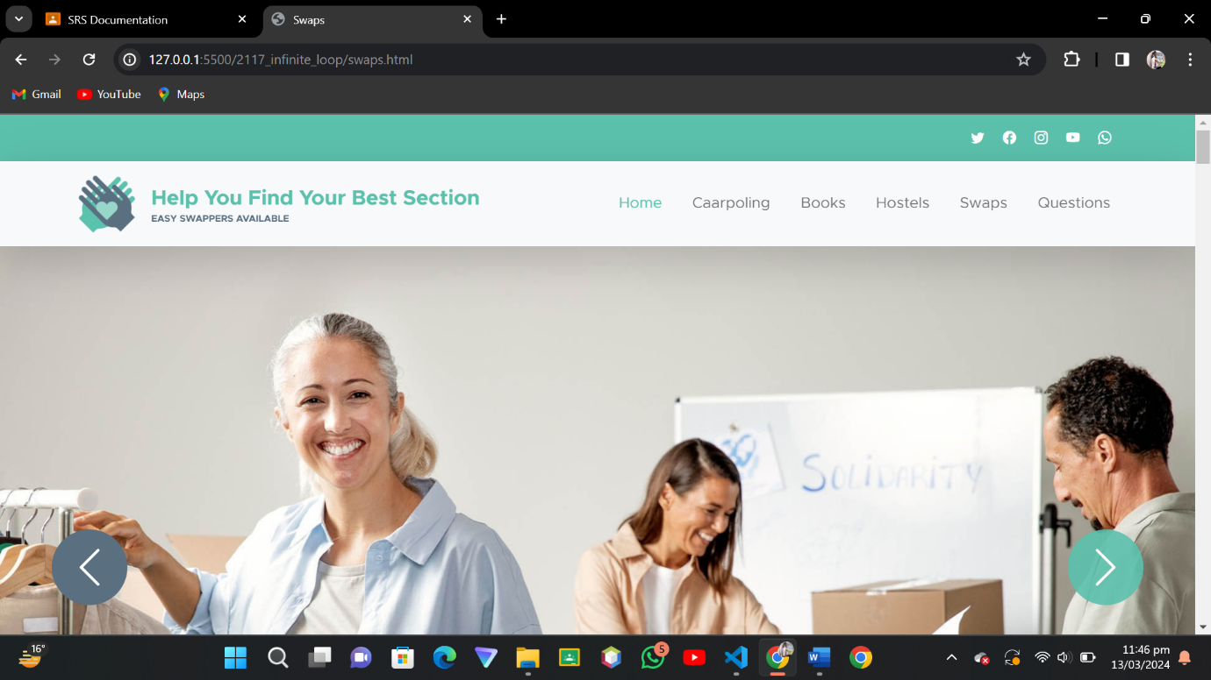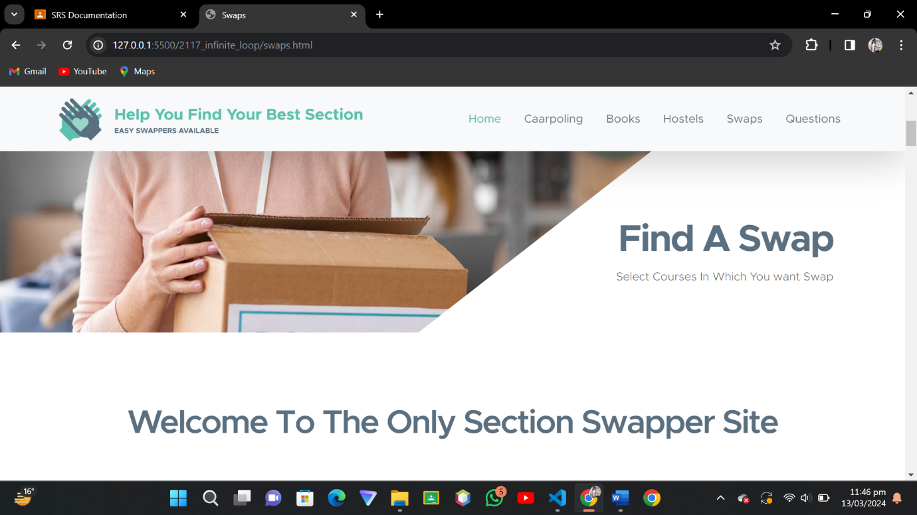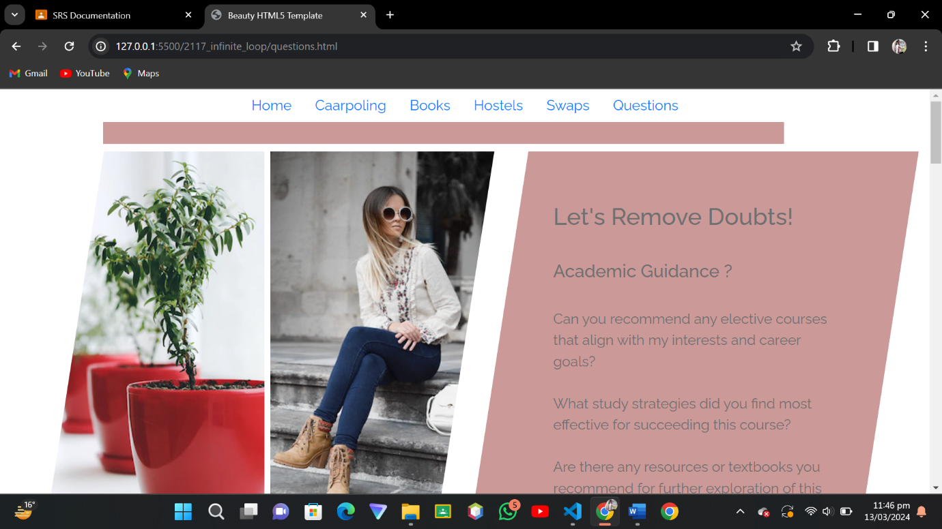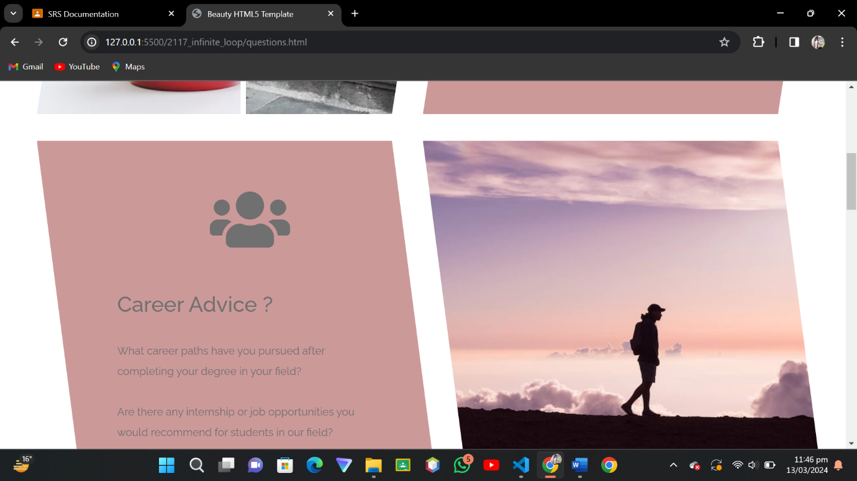

**3.2 Hardware Interfaces**

The FAST-NUCES Student Portal is a web-based application that does not require any direct interaction with hardware components. As such, there are no specific hardware interfaces to describe. The system is designed to be compatible with standard computing devices such as personal computers, laptops, tablets, and smartphones. Users can access the application through web browsers without the need for specialized hardware configurations.

**3.3 Software Interfaces**

The FAST-NUCES Student Portal interacts with various software components to provide its functionality. These software interfaces include:

**Databases**:

The application communicates with a MongoDB database to store and retrieve user data, group information, and content shared within the platform. MongoDB version 4.4 or later is recommended for optimal performance.

**Operating Systems**:

The web application is platform-independent and can run on any operating system that supports modern web browsers, including Windows, macOS, Linux, iOS, and Android.

**Tools and Libraries**:

The development of the FAST-NUCES Student Portal utilizes several tools and libraries within the MERN (MongoDB, Express.js, React.js, Node.js) stack. These include:

**Node.js:**

Version 14.17.0 or later is used as the server-side JavaScript runtime environment.

**Express.js:**

Version 4.17.1 or later is employed as the web application framework for Node.js, facilitating the creation of robust APIs.

**React.js**:

Version 17.0.2 or later is utilized for building the user interface components, providing a dynamic and interactive user experience.

**npm (Node Package Manager):**

Version 7.17.0 or later is utilized for managing project dependencies and scripts.

Various npm packages and libraries are incorporated for tasks such as routing, state management, and data validation.

**Integrated Commercial Components:**

The application may integrate with third-party services or APIs for functionalities such as authentication, email notifications, and analytics. For example, OAuth 2.0 may be used for secure user authentication and authorization.

**Communication Protocols:**

The communication between the client-side (browser) and server-side components of the application occurs over standard HTTP/HTTPS protocols. WebSocket protocol may also be utilized for real-time communication in certain features, such as chat functionality.

Data Sharing Mechanism: Data exchange between different software components within the system occurs primarily through RESTful APIs. JSON (JavaScript Object Notation) is used as the preferred data interchange format, providing a lightweight and platform-independent means of exchanging data.

**3.4 Communications Interfaces**

Communication will primarily occur through standard web protocols such as HTTP and WebSocket for real-time interactions.

Sure, here's the continuation of the template with the system features and non-functional requirements sections:

**4. System Features**

**4.1 Carpooling**

**4.1.1 Description and Priority**

Facilitating students to organize carpooling arrangements.

**Priority:**

High.

**4.1.2 Stimulus/Response Sequences**

**Stimulus:**

User selects the "Carpooling" feature from the main menu.

**Response:**

The system displays a list of available carpooling arrangements, including driver details, pickup/drop-off locations, and schedules.

**4.1.3 Functional Requirements**

**REQ-1 :**

Users can create carpooling listings, specifying their role as a driver or passenger, pickup/drop-off points, and preferred schedule.

**REQ-2:**

Users can search and view existing carpooling arrangements, filtering by criteria such as location and time.

**REQ-3:**

Users can request to join a carpooling arrangement as a passenger or accept requests from others if they are the driver.

**REQ-4:**

The system should notify users of any updates or changes to carpooling arrangements they are involved in.

**REQ-5:**

Users can rate and provide feedback on their carpooling experiences.

**4.2 Academic Resource Sharing**

**4.2.1 Description and Priority**

Providing a platform for sharing and accessing books and study materials.

**Priority**: High.

**4.2.2 Stimulus/Response Sequences**

**Stimulus**: User selects the "Academic Resource Sharing" feature from the main menu.

**Response**: The system displays a library of available resources, including books, notes, and past papers, categorized by subject.

**4.2.3 Functional Requirements**

**REQ-1**: Users can upload and share academic resources, including textbooks, lecture notes, and past exam papers.

**REQ-2**: Users can search and browse for resources by subject, author, or keyword.

**REQ-3**: The system should support file formats commonly used for academic resources such as PDF, DOCX, and PPT.

**REQ-4:** Users can rate and review resources to provide feedback for other users.

**REQ-5:** The system should have mechanisms to prevent the distribution of copyrighted materials without proper authorization.

**4.3 Anonymous Advice**

**4.3.1 Description and Priority**

Allowing students to seek and offer advice on courses and instructors anonymously.

**Priority**: Medium.

**4.3.2 Stimulus/Response Sequences**

**Stimulus**:

User accesses the "Anonymous Advice" section of the platform.

**Response**:

The system presents a forum-like interface where users can post questions and responses without revealing their identities.

**4.3.3 Functional Requirements**

**REQ-1:** Users can post questions related to courses, instructors, or academic advice anonymously.

**REQ-2:** Users can respond to posted questions and provide advice anonymously.

**REQ-3:** The system should have moderation tools to ensure that posted content adheres to community guidelines.

**REQ-4:** Users can upvote or downvote responses to indicate helpfulness and relevance.

**4.4 Accommodation Information**

**4.4.1 Description and Priority**

Enabling students to access information about hostel room vacancies and off-campus accommodation options.

**Priority**: Medium.

**4.4.2 Stimulus/Response Sequences**

**Stimulus**:

User navigates to the "Accommodation Information" section.

**Response**:

The system displays a list of available hostel room vacancies and off-campus accommodation listings.

**4.4.3 Functional Requirements**

**REQ-1:**

Users can search for hostel room vacancies based on criteria such as location, room type, and availability.

**REQ-2:**

Users can post listings for off-campus accommodation options, including details such as rent, location, and contact information.

**REQ-3:**

The system should have a messaging feature to facilitate communication between students interested in accommodation listings.

**4.5 Cross-University Discussions**

**4.5.1 Description and Priority**

Providing separate groups for discussions with students from other universities, allowing users to choose whether to reveal their identities.

**Priority**: Low.

**4.5.2 Stimulus/Response Sequences**

**Stimulus**:

User accesses the "Cross-University Discussions" feature.

**Response**:

The system presents a list of discussion groups categorized by topic, with options to join and participate anonymously.

**4.5.3 Functional Requirements**

**REQ-1:**

Users can create discussion groups on various topics and invite participants from other universities.

**REQ-2:**

Users can choose to participate in discussions anonymously or reveal their identities.

**REQ-3:**

The system should have moderation tools to ensure discussions remain respectful and on-topic.

**REQ-4:**

Users can search for and browse existing discussion groups by topic and university.

**5. Other Nonfunctional Requirements**

**5.1 Performance Requirements**

- The system should load within 3 seconds on standard internet connections.

- Response time for user interactions should be less than 0.5 seconds.

- The system should be able to handle concurrent requests from at least 1000 users without significant performance degradation.

**5.2 Safety Requirements**

- The system should encrypt user data during transmission to ensure data security.

- Backup mechanisms should be in place to prevent data loss in case of system failure.

**5.3 Security Requirements**

- User authentication should be implemented using JWT tokens to prevent unauthorized access.

- Access to sensitive user information should be restricted based on user roles and permissions.

**5.4 Software Quality Attributes**

- Usability: The system should provide an intuitive user interface to ensure ease of use.

- Reliability: The system should be available 24/7 with minimal downtime for maintenance.

**5.5 Business Rules**

- Only registered users should be able to access certain features such as carpooling and academic resource sharing.

**6. Other Requirements**

**Appendix A:** Glossary

**Appendix B:** AnalysisModels

**Appendix C:** To BeDeterminedList